Convolutional Neural Networks (CNNs)

Teaching a computer to recognize objects in images requires processing hundreds of thousands of pixels while understanding that spatial relationships matter (pixels form edges, edges form shapes, shapes form objects). Convolutional Neural Networks (CNNs) are designed specifically for this challenge, using convolutional layers that scan for local patterns and build hierarchical representations automatically. In this lesson, we'll explore the building blocks that make CNNs work: how they detect features, reduce complexity, and make predictions.
1. The Building Blocks of CNNs
1.1 Convolutional Layers: Detecting Patterns
When identifying a friend in a crowded photo, your eyes scan for distinctive features: face shape, hairstyle, smile. Convolutional layers work similarly, systematically scanning images to detect local patterns.
How it works:
A convolutional layer uses small filters (or kernels)—typically 3×3 or 5×5 pixel grids. Each filter slides across the entire image, examining one small region at a time, looking for specific patterns: vertical edges, curves, color gradients, textures.
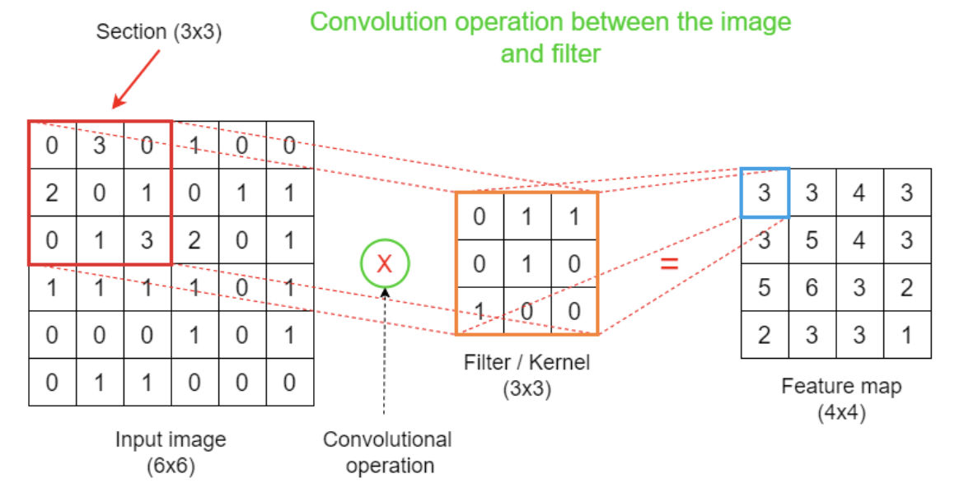
Figure - Convolution Operation: A 3×3 filter slides across the input image, performing element-wise multiplication and summation at each position to produce a feature map.
Figure - Convolution Operation: A 3×3 filter slides across the input image, performing element-wise multiplication and summation at each position to produce a feature map.
The mathematical operation is convolution: at each position, the filter multiplies its values element-wise with the underlying pixel values, then sums the results to produce a single number. Repeating this across the entire image creates a feature map—highlighting where the filter detected its pattern.
$$\text{Output}(i,j)=\sum_{m}{\sum_{n}{\text{Input}(i+m,j+n)×\text{Filter}(m,n)}}$$
Intuition: Think of a convolutional filter like a template. You slide it across an image, and at each position, you measure how well the image matches the template. Strong matches produce high values (activations), weak matches produce low values. The feature map is the collection of all these measurements.
The hierarchical advantage:
Early layers detect simple features (edges, corners). Deeper layers combine these into complex patterns (textures, object parts, entire objects). This hierarchical feature learning is built into the architecture.
1.2 Pooling Layers: Reducing Dimensionality
After extracting features, CNNs face a computational challenge: feature maps can be enormous, leading to millions of parameters. Pooling layers solve this by reducing size while preserving essential information.
Max pooling is the most common approach: divide the feature map into small grids (typically 2×2), keep only the maximum value from each grid, discard the rest.
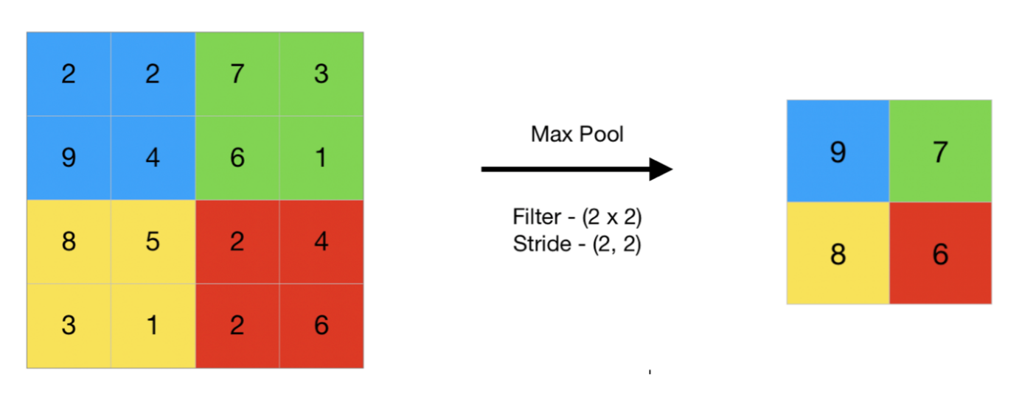
Figure - Max Pooling: A 2×2 filter with stride 2 reduces a 4×4 feature map to 2×2 by keeping only maximum values from each region.
Why this works:
Consider edge detection. If a filter found a vertical edge somewhere in a 2×2 region, the exact position doesn't matter—just that the edge exists in that area. Max pooling captures "this feature is present" while dramatically reducing data volume.
Benefits:
- Reduces parameters: Faster training, less memory
- Translation invariance: Small spatial shifts don't affect detection
- Regularization: Less information forces learning of robust features
1.3 Fully Connected Layers: Making Predictions
After convolutional and pooling layers extract features, fully connected layers make the final prediction—the same dense layers from standard neural networks.
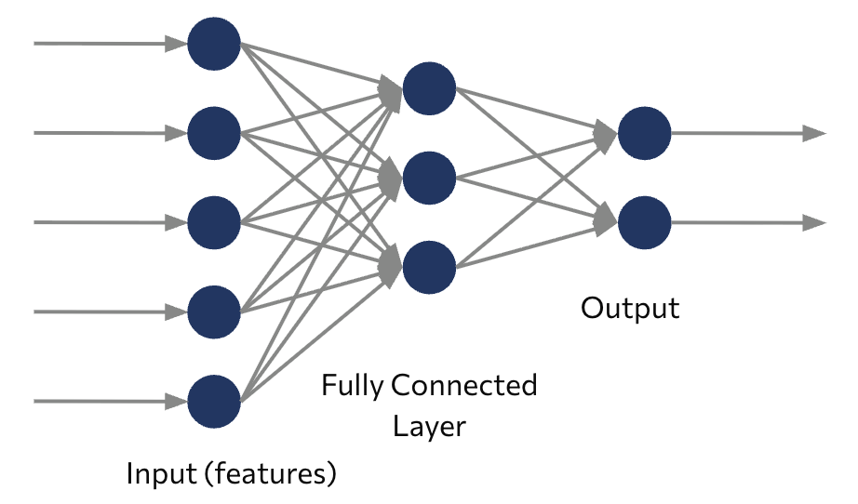
Figure - Fully Connected Layer: Every neuron connects to all neurons in the previous layer, combining extracted features to make final predictions.
CNN architecture has two phases:
- Feature extraction (convolutional + pooling): Learn increasingly complex visual features
- Classification (fully connected): Combine features to make predictions
The transition happens by flattening the final feature maps into a vector, which feeds into fully connected layers. These layers learn to recognize combinations: "whiskers + pointed ears + fur texture = cat."
The complete picture: CNNs alternate convolutional and pooling layers multiple times, progressively extracting more abstract features, then use fully connected layers to map features to predictions. A 224×224×3 input might transform through many layers into 1000 output class probabilities.
2. Landmark CNN Architectures
2.1 The Pioneers: LeNet and AlexNet
CNN history is marked by breakthrough moments that redefined computer vision.
LeNet-5 (1998)
The original CNN, designed by Yann LeCun for handwritten digit recognition. Banks used it to automatically read check numbers—revolutionary for its time. With just a few layers, it proved CNNs could learn visual patterns better than hand-crafted features.
AlexNet (2012)
The watershed moment. In the ImageNet competition (1.2 million images, 1000 categories), AlexNet didn't just win—it dominated, reducing error rates by an unprecedented margin. This sparked the deep learning revolution.
AlexNet's innovations:
- ReLU activations (faster training than sigmoid/tanh)
- Dropout for regularization
- GPU computing at unprecedented scale
- Proof that deeper networks with more data win
Paradigm shift: Before AlexNet, computer vision relied on hand-crafted features (SIFT, HOG) designed by experts. AlexNet demonstrated that neural networks could automatically learn superior features from data—opening the floodgates for deep learning research.
2.2 Modern Innovations: VGG, Inception, and ResNet
After AlexNet proved CNNs work, researchers pushed further.
VGG (2014): Simplicity Through Depth
VGG's answer: extreme simplicity. Stack many 3×3 convolutions. VGG-16 has 16 layers, VGG-19 has 19. The insight? Multiple small filters capture the same patterns as larger filters but with fewer parameters and more non-linearity.
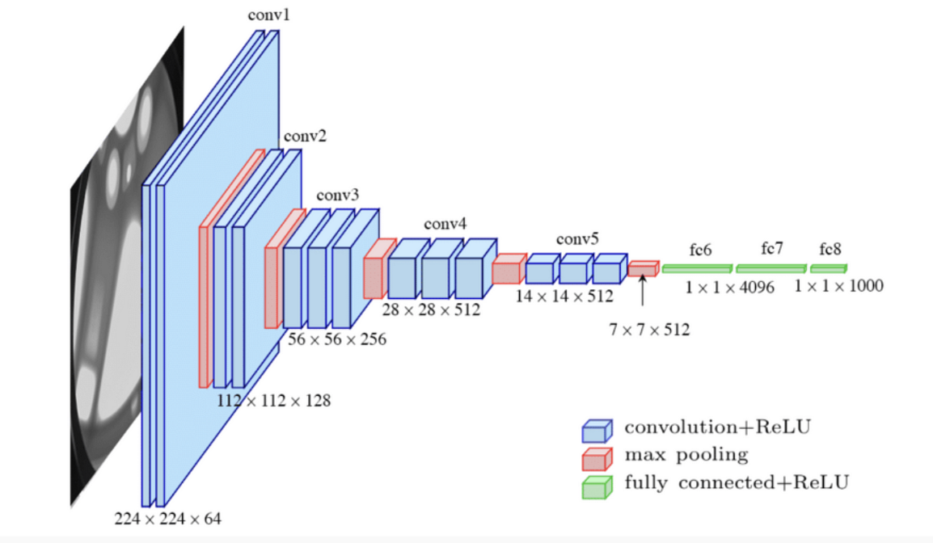
Figure - VGG-16 Structure: Convolutional blocks (blue) extract features, pooling layers (red) reduce dimensions, fully connected layers (green) produce final classifications.
Inception/GoogLeNet (2014): Parallel Processing
Inception modules use multiple filter sizes (1×1, 3×3, 5×5) in parallel at each layer. Why choose one filter size when the network can try all and learn which matters? Won ImageNet 2014.
ResNet (2015): Enabling Extreme Depth
ResNet solved a critical problem: very deep networks (50+ layers) became harder to train despite theoretical advantages. The solution: residual connections (skip connections) allowing information to bypass layers. Instead of learning transformations directly, layers learn corrections to the input.
This breakthrough enabled networks with 152 layers, even 1000+, revolutionizing what's achievable.
Architectural evolution:
- LeNet: CNNs work (7 layers)
- AlexNet: Scale matters (8 layers)
- VGG: Depth and simplicity (16-19 layers)
- Inception: Parallel architectures (22 layers)
- ResNet: Extreme depth enabled (50-152+ layers)
Each generation solved new challenges while building on previous insights.
Key Takeaways
- CNNs are designed for visual data, using convolutional layers that preserve spatial structure by scanning images with learnable filters, detecting simple features in early layers, complex objects in deeper layers
- Three core components work together: convolutional layers extract features through sliding filters, pooling layers reduce dimensionality while preserving key information, fully connected layers make final predictions
- Convolution involves sliding filters across images, performing element-wise multiplication and summation to create feature maps. This dramatically reducing parameters compared to fully connected networks through weight sharing
- Pooling (especially max pooling) provides translation invariance and regularization by keeping only the strongest activations from local regions, reducing computational demands by 75% or more
- CNN architectures evolved from LeNet-5 (1998 proof of concept) through AlexNet (2012 breakthrough) to modern innovations: VGG (deep simplicity), Inception (parallel modules), ResNet (skip connections enabling 100+ layers)

